**Assignment 11.3 Flume**

**Problem Statement:**

**Mentioned all the steps:**

Create a flume agent that streams data from Twitter and stores in the HDFS.

<https://acadgild.com/blog/streaming-twitter-data-using-flume/>

Move file from Downloads to lib folder

mv /home/acadgild/Downloads/apache-flume-1.6.0-bin/ /usr/local/flume/lib

copy flume.conf

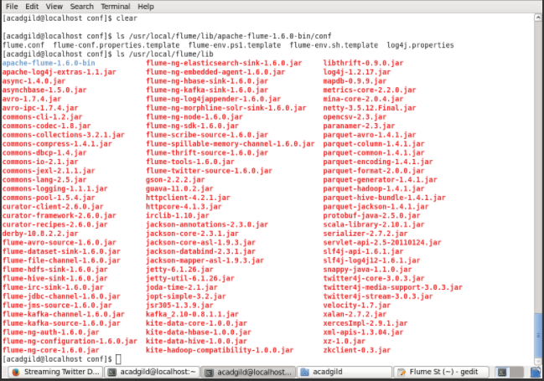

copy flume.conf  
mv /home/acadgild/flume.conf/ /usr/local/flume/lib/apache-flume-1.6.0-bin/conf  
  
create a new dir in below location:  
Hadoop fs –mkdir –p /user/flume/tweets  
  
cd $FLUME_HOME/bin  
flume-ng agent -n TwitterAgent -f /usr/local/flume/lib/apache-flume-1.6.0-bin/conf/flume.conf

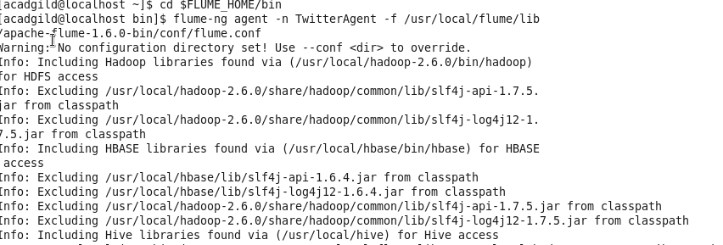

**Hadoop ds –mkdir –p /user/flume/tweets**

